**AWS CLOUD PRACTITIONER**

**Section 5: EC2 Instance Storage:**

1. **EBS Overview:**

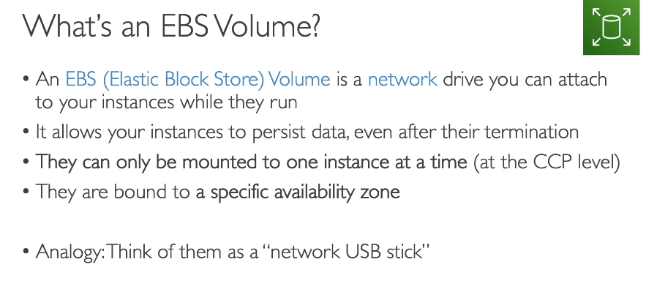

EBS volume stands for Elastic Block Store.

It's a network drive that you cannot attach

to your instances while they run.

And we've been using them without even knowing.

So this EBS Volumes allow us to persist data

even after the instance is terminated.

And so that's the whole purpose.

We can recreate an instance

and mount the same EBS Volume from before,

and we will get back our data.

That is very helpful.

So these EBS Volumes at the CCP level can only be mounted

to one instance at a time, okay?

And when you create an EBS Volume,

it is bound to a specific availability zone.

That means that you cannot have an EBS Volume in created,

for example, us-east 1a attached

to an instance in us-east 1b.

We'll see this in the diagram in a second.

So how do you think of EBS Volumes?

Well, you can think of them as network USB sticks.

So it's a USB stick that you can take from a computer

and put it in another computer,

but you actually don't physically put it in a computer.

Amazon Elastic Block Store (**EBS**) is a high-performance **block-level storage** service for Amazon EC2 instances. While it's a network-attached service and not physically inside the EC2 instance, it functions like a local hard drive. This network connection is what allows it to be **persistent** and separate from the life of the EC2 instance.

An **EBS volume** is a **network-attached storage** device. In simple terms, this means it's a virtual hard drive that is connected to an EC2 instance over the network, not with a physical cable.

Think of it like this:

* **Local Hard Drive (Ephemeral):** Imagine a hard drive plugged directly into your computer's motherboard. If you unplug the computer or the motherboard fails, the hard drive is no longer connected. This is similar to an EC2 Instance Store.
* **EBS (Network-Attached):** Imagine a shared drive in an office. It's a server in another room that all the computers can connect to through the office network. Even if one computer shuts down, the data on the shared drive is safe and can be accessed by another computer. This is how an EBS volume works.

This network-attached design is a key feature of AWS's architecture and provides several major benefits:

* **Persistence**: Data on an EBS volume is **not tied to the life of the EC2 instance**. If you stop or terminate your EC2 instance, the EBS volume and all its data remain available. You can then attach that same volume to a different EC2 instance in the same Availability Zone.
* **Scalability**: Since EBS volumes are separate from the EC2 instance's hardware, you can easily resize them, change their performance characteristics, and even move them to another instance without any downtime.
* **High Availability**: EBS volumes are automatically replicated within their Availability Zone to protect against a single hardware failure.

An EBS volume is a **virtual hard drive** that works by communicating with an EC2 instance over a high-speed network. Unlike a traditional hard drive that's physically installed inside a computer, the EBS volume exists on a separate storage server within the AWS data center.

Here's how it works step-by-step:

**1. You Create an EBS Volume**

When you create an EBS volume, you're essentially allocating a block of storage space on a dedicated storage server in an AWS data center. This storage server is highly available and redundant.

**2. You Attach it to an EC2 Instance**

When you attach the EBS volume to your EC2 instance, the AWS system creates a network link between the two. The EC2 instance's operating system sees the EBS volume as a standard local block device, just like a hard drive. It gets a device name (e.g., /dev/xvda).

**3. Data is Transferred Over the Network**

When you read or write data to the EBS volume from your EC2 instance, the data packets are sent over the network to the storage server. The storage server then processes the request and either retrieves the data or stores the new data. This entire process happens with very low latency, making it feel like a local disk.

**4. It's Independent and Persistent**

Because the storage is on a separate server, it's not tied to the life of the EC2 instance. If the instance is stopped or terminated, the network connection is broken, but the EBS volume remains intact on the storage server. You can then attach it to a new EC2 instance, and all your data will be there, ready to go. This is what makes it a **persistent** form of storage.

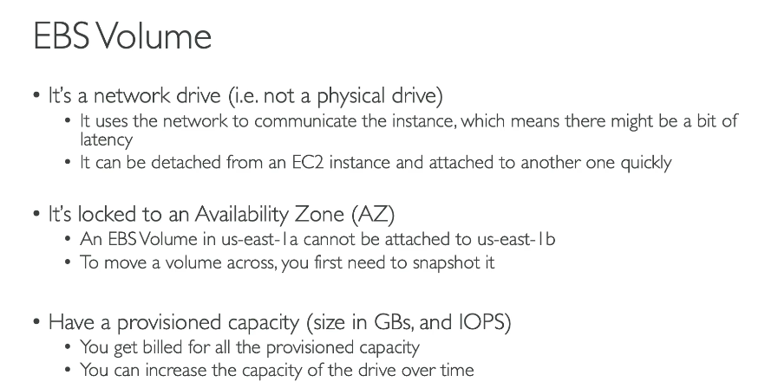

Now let's look at it.

So EBS Volumes are network drive,

as I said, it's not a physical drive, okay?

So to communicate between the instance

and the EBS Volume, it will be using the network.

And because their network is used,

there may be a bit of latency from one computer

to reach to another server.

Now, EBS Volumes, because there are a network drive

that can be detached from an EC2 instance

and attached to another one very quickly.

And that makes it super handy

when you want to do failovers, for example.

EBS Volumes are locked to a specific Availability Zones.

That means that, as I said, if it's created in us-east 1a,

it cannot be attached to us-east 1b.

But we will see in this section that if we do a snapshot,

then we are able to move a volume across

from different availability zones.

And finally, it's a volume.

So you have to provision capacity in advance.

So you need to say how many gigabytes you want in advance,

and the IOPS, which is IO operations per second.

And you're basically defining

how you want your EBS volume to perform.

You're going to get billed for that provision capacity,

and you can increase the capacity over time if you want

to have better performance or more size.

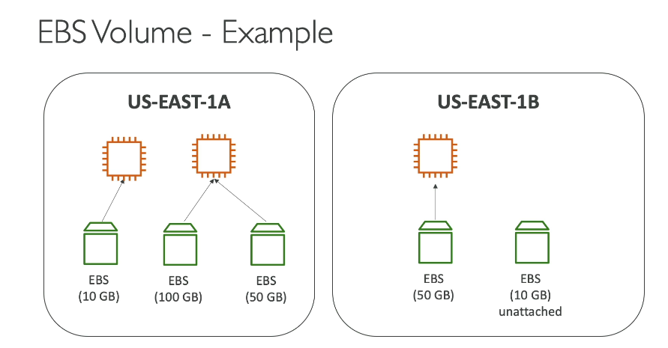

So as a diagram, what does it look like.

Well, we have us-east 1a, we have one EC2 instance,

and we can attach, for example, one EBS Volume

to that EC2 instance.

If we create another EC2 instance, as I said,

an EBS Volume cannot be attached

to two instances at a time at the certified

cloud practitioner level.

And therefore, what I wanna say is

that this other EC2 instance needs

to have its own EBS volume attached to it,

but it is very possible for us

to have two EBS volumes attached to one instance.

Think of it as two network USB sticks into one machine.

That makes a lot of sense.

Now, EBS volumes are linked to an availability zone.

So as we can see, all this diagram has been

so far using us-east 1a.

So if you wanted to have other EBS volumes in other AZ,

then you would need to create this separately

in the other availability zone.

So just same way that your EC2 instances are bound to an AZ,

so are the EBS Volumes.

Finally, it is possible for us to create EBS Volumes

and leave them unattached that don't need

to be necessarily attached to an EC2 instance

that can be attached on demand,

and that makes it very, very powerful.

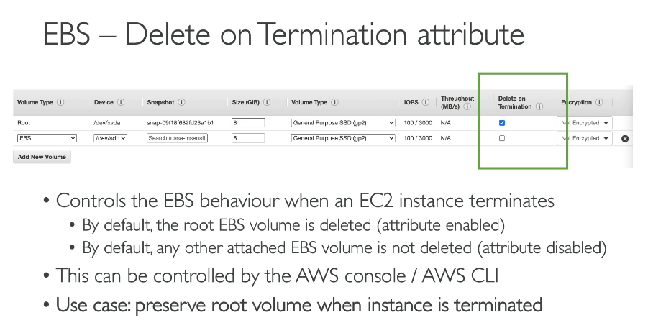

The provided text explains the **"Delete on Termination"** attribute for Amazon EBS volumes attached to an EC2 instance. This setting determines what happens to the EBS volume when the EC2 instance is terminated.

* **Root Volume:** The **root EBS volume** (the one with the operating system) has the "Delete on Termination" attribute **enabled by default**. This means that when you terminate an EC2 instance, the root volume is also deleted.
* **Other Volumes:** Any **additional EBS volumes** you attach to an instance have the "Delete on Termination" attribute **disabled by default**. This means that if you terminate the EC2 instance, these volumes are not deleted and will persist.
* **Customization:** You can **change this default behavior** in the EC2 launch wizard. You can disable "Delete on Termination" for the root volume to save data on it even after the instance is terminated.

1. **EBS Hands On:**

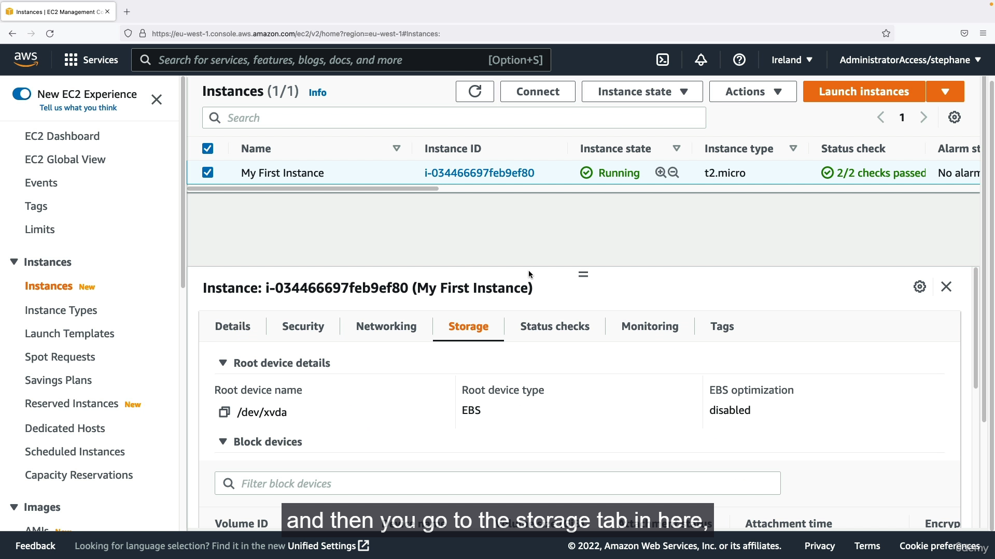

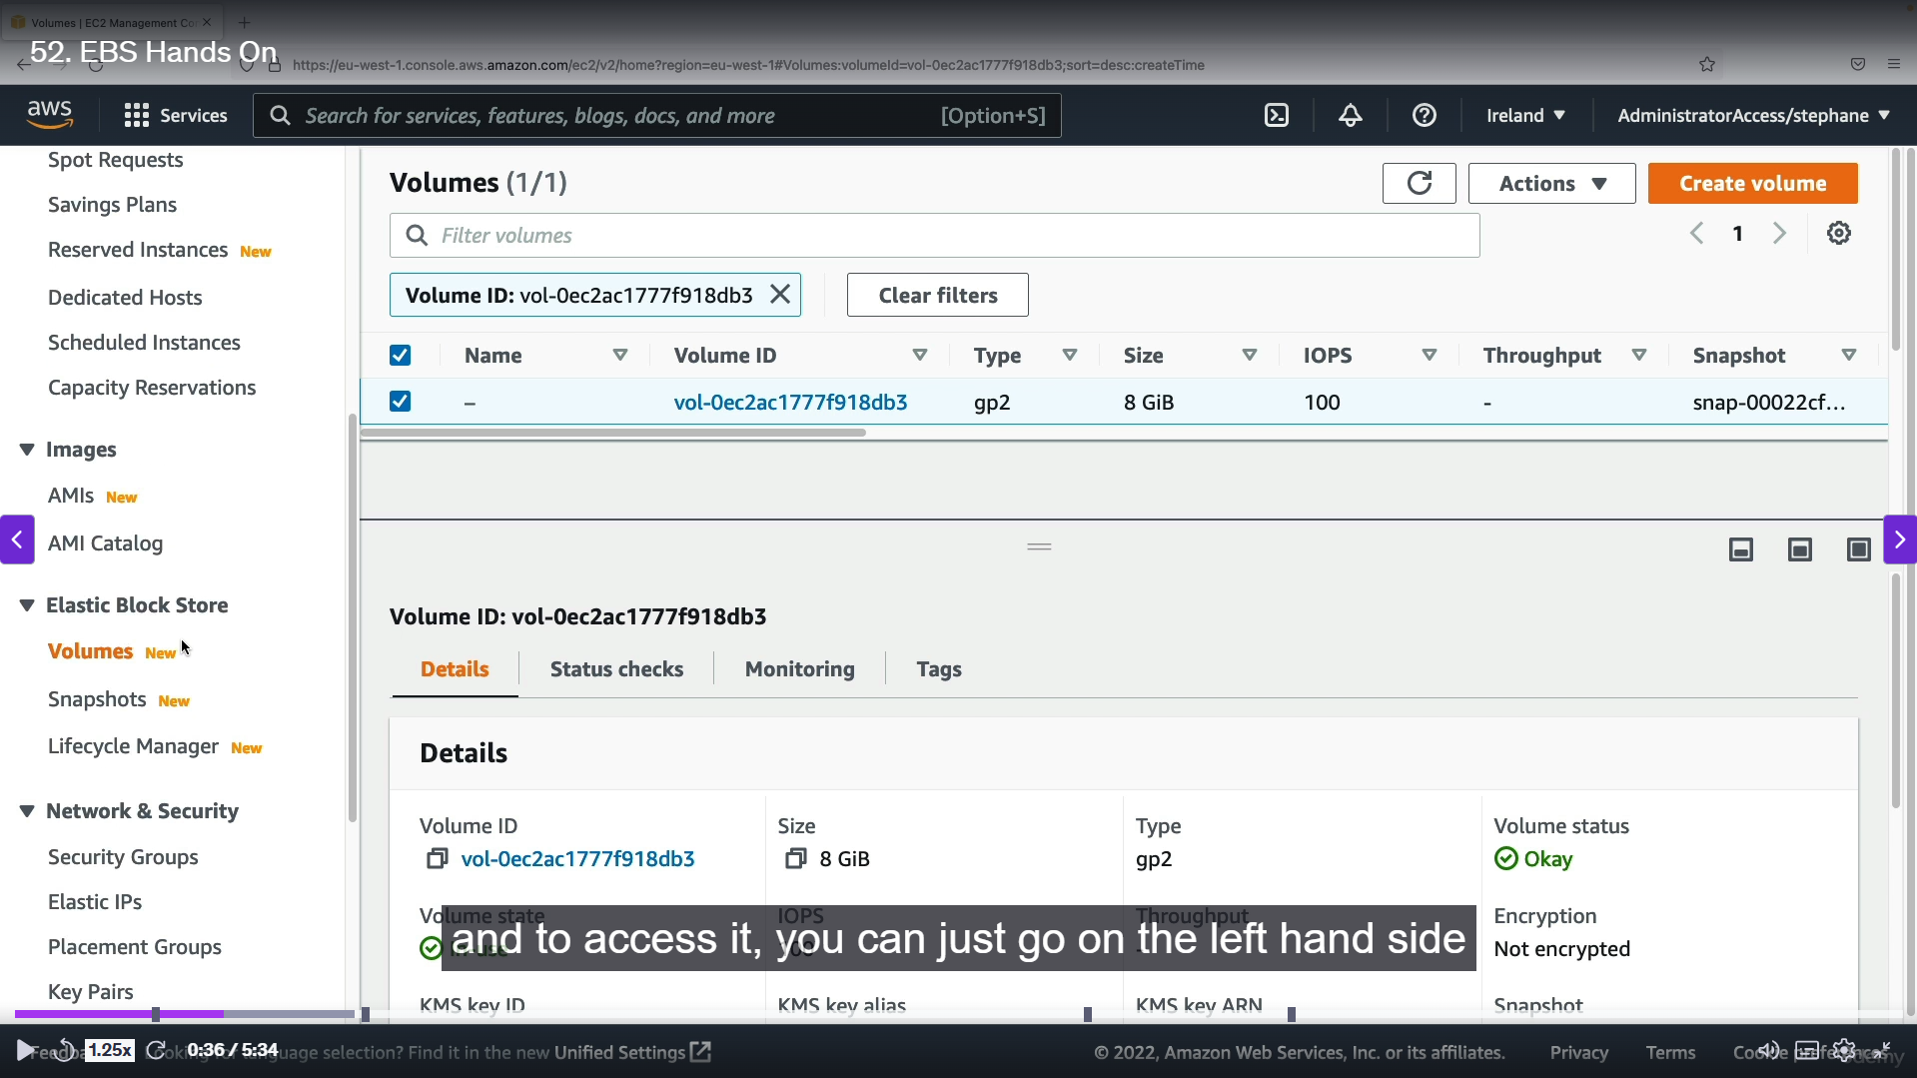

Step 1: After creating the instanaces, by default we will create a root volume which is attached to the instances. We can see that by select the instances and click on storage for seeing the EBS.

Step 2: Otherwise on the left side there will be storage option in that we can see in detail.

Step 3: After went to that option, we can see for that volume there will be volume ID, size and all the information.

Step 4: We can create a new volume by selecting the create volume option.

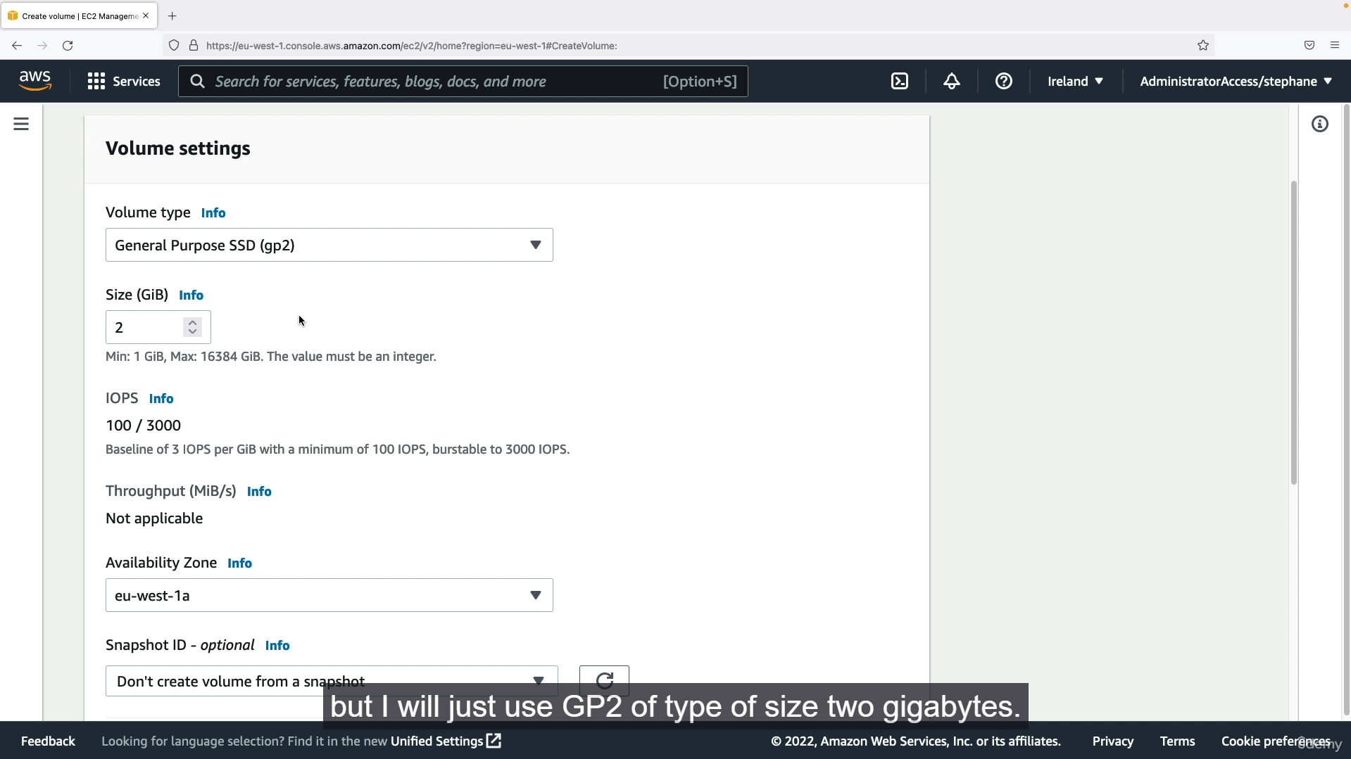

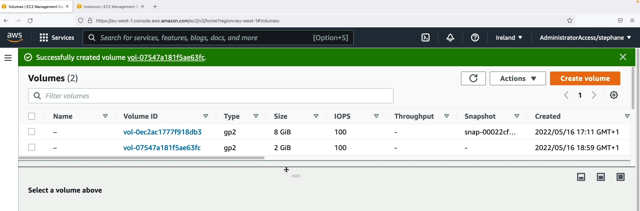

Step 5: Fill the volume creating settings like, volume type, size, availability zone (make sure AZ is same as the instances you created). Otherwise, you will not be able to attach that volume to the instances you created.

Step 6: After creating the instances, in volume section it will show two volumes, Next step is to attach that volume to that instances.

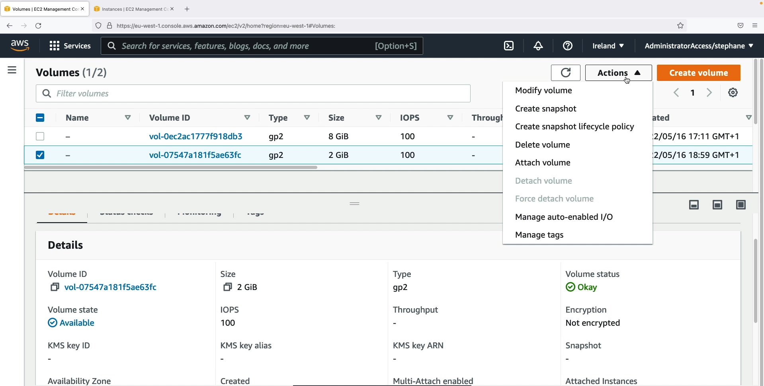

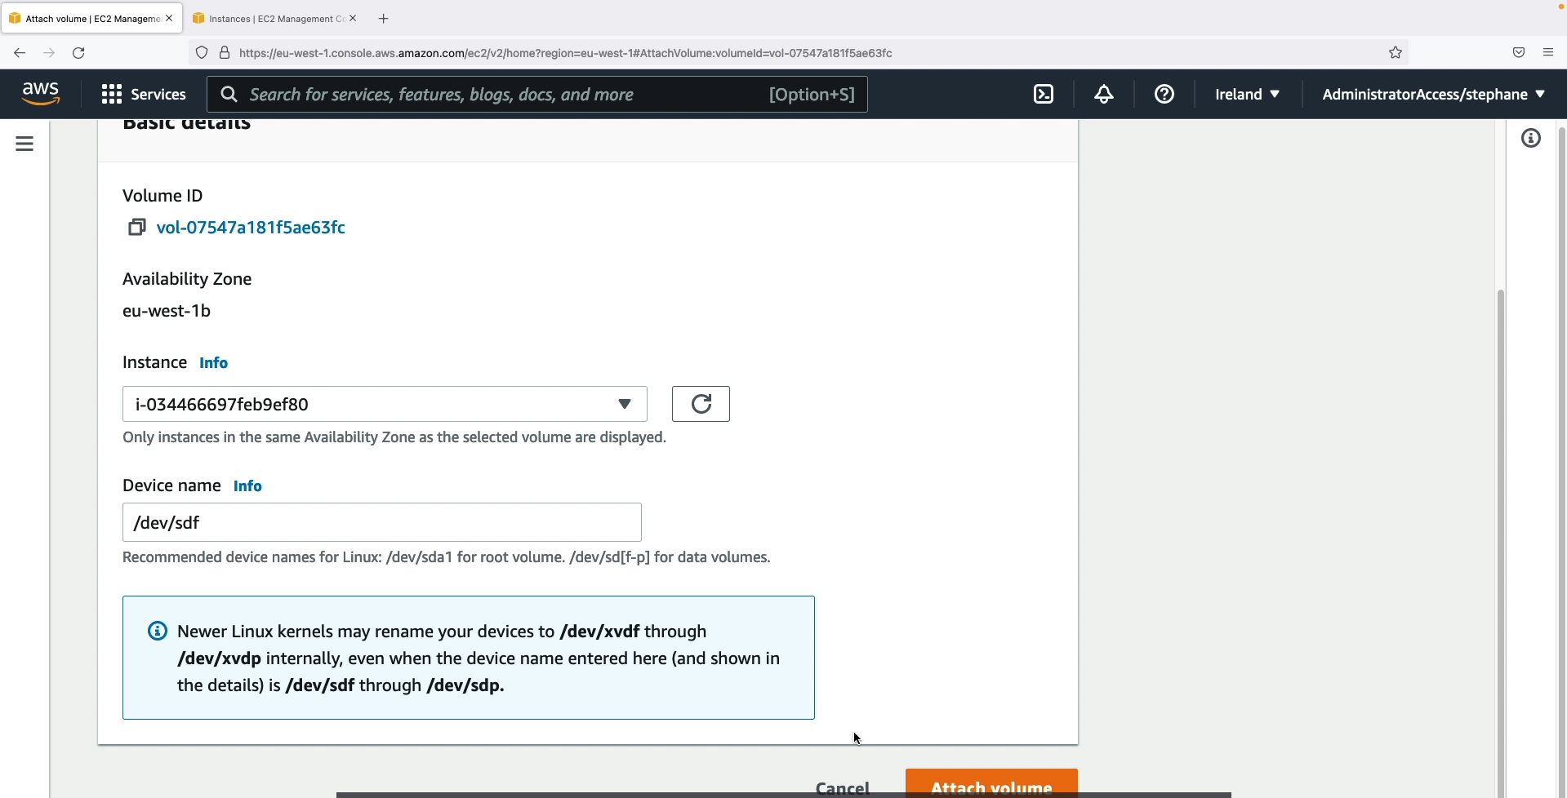

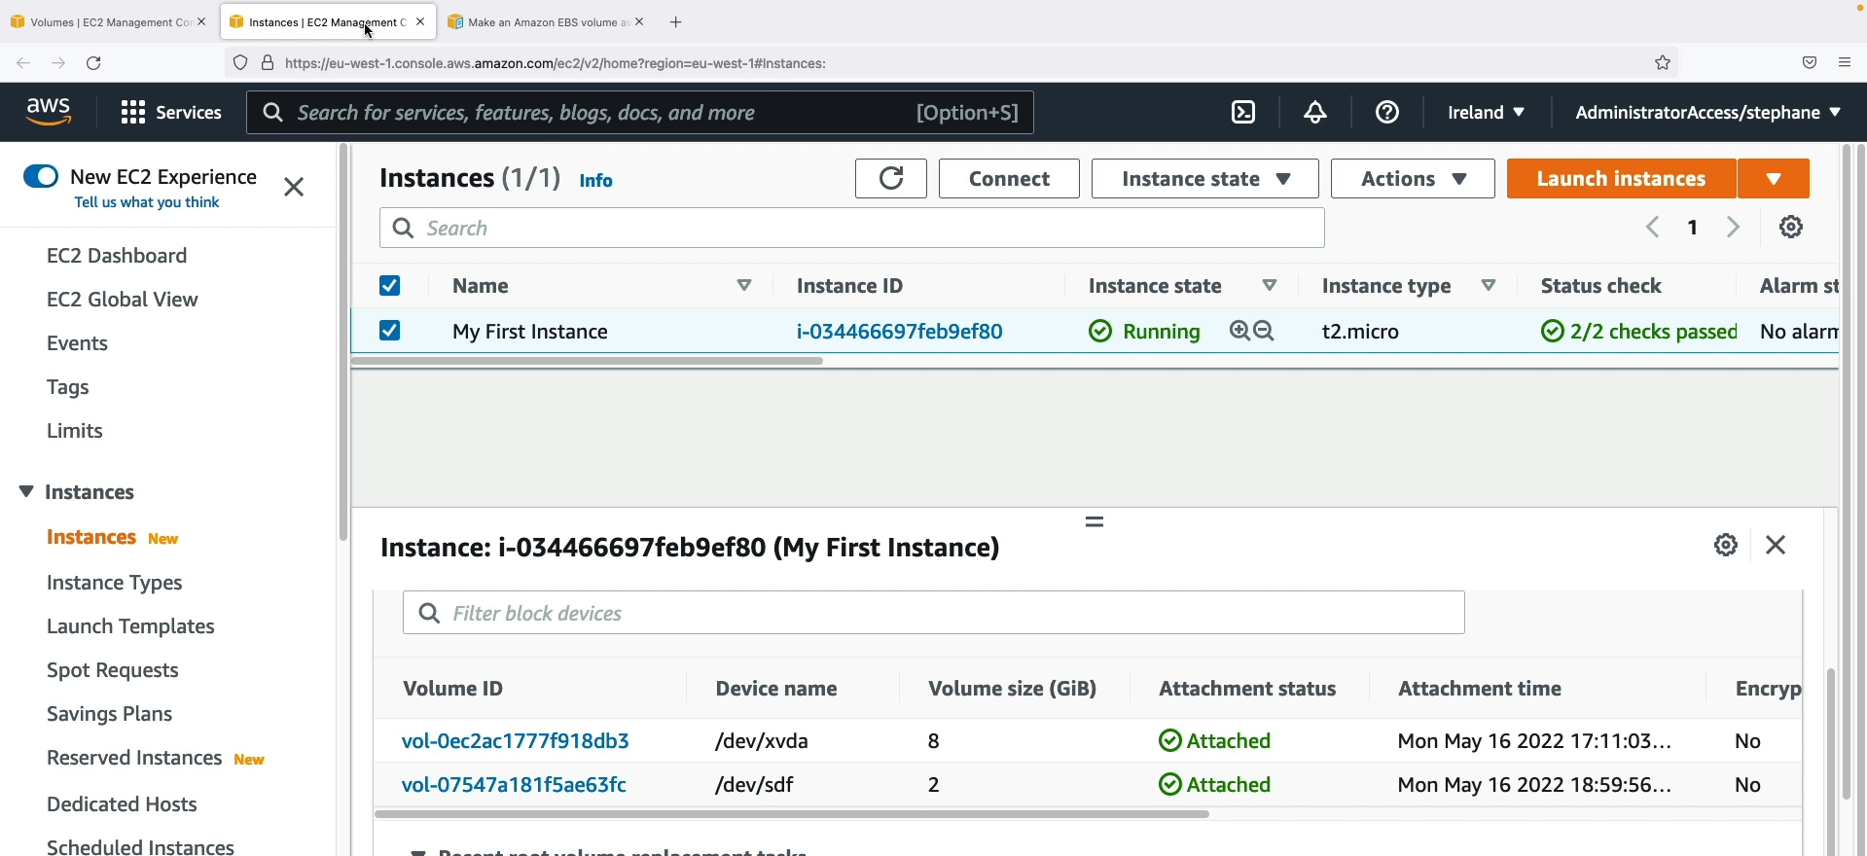

Step 7: Select the volume and select the actions option. In that it will show attach volume select that and enter the instance id you want to attach. The instance will show in the dropdown which are created in the same AZ.

Step 8: After attach the volume to that instance, in instance section in storage it will show that two volumes are attached to that instance.

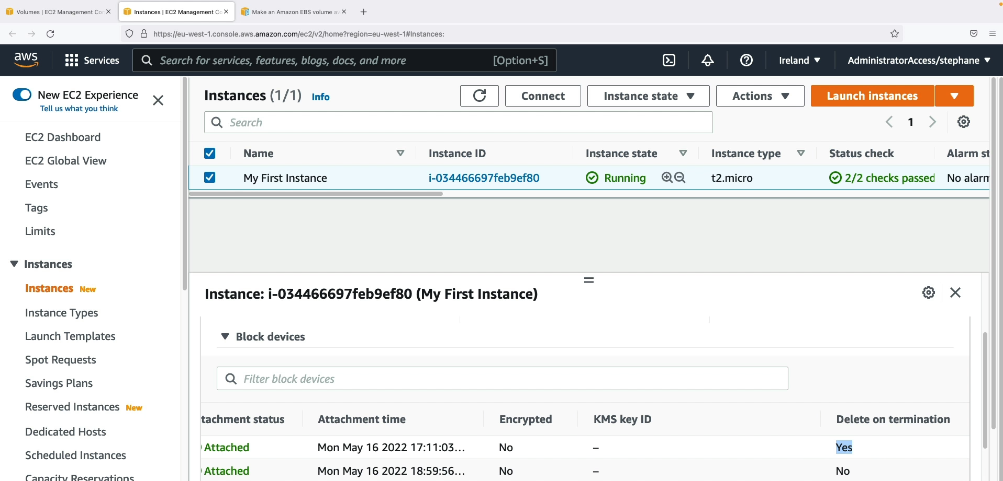

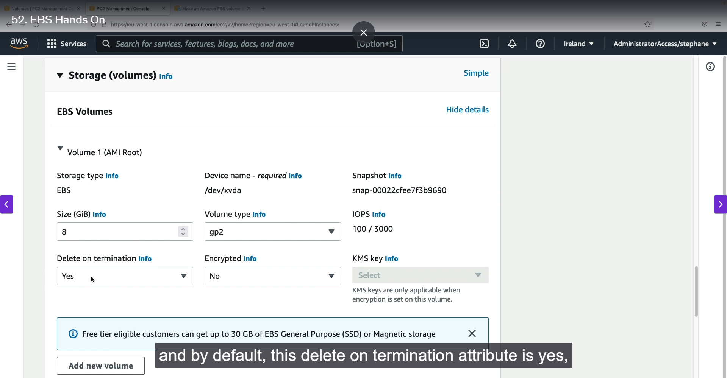

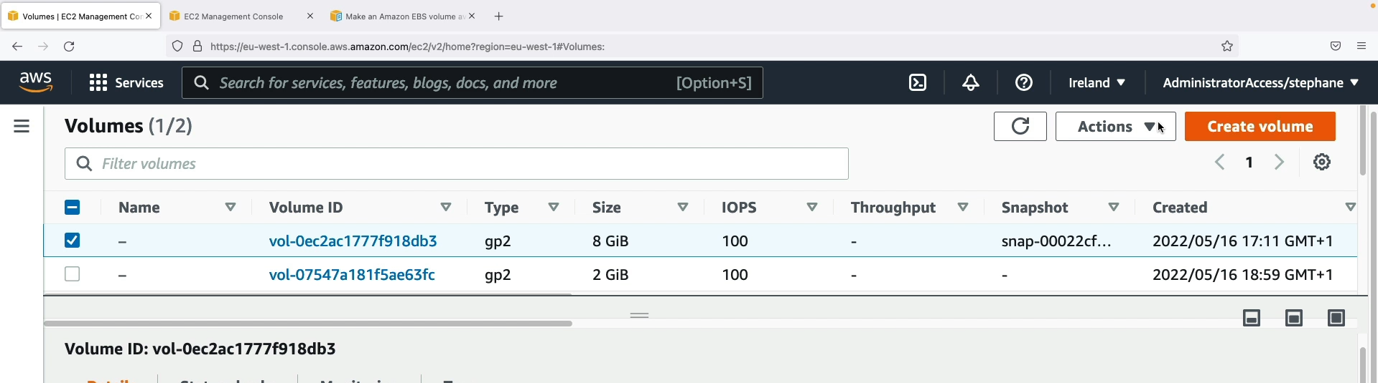

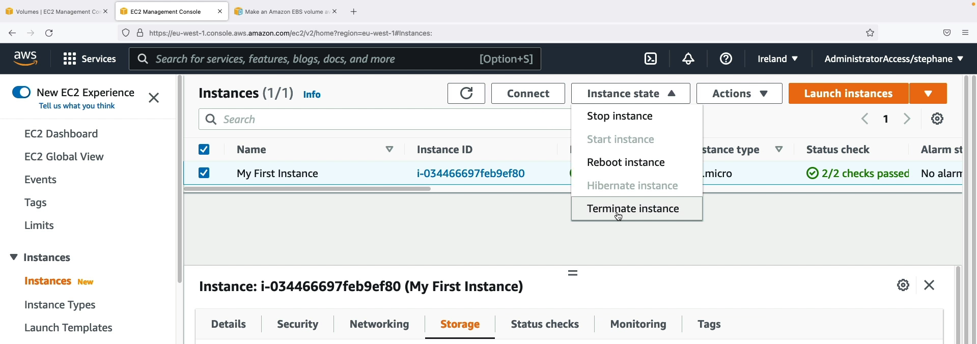

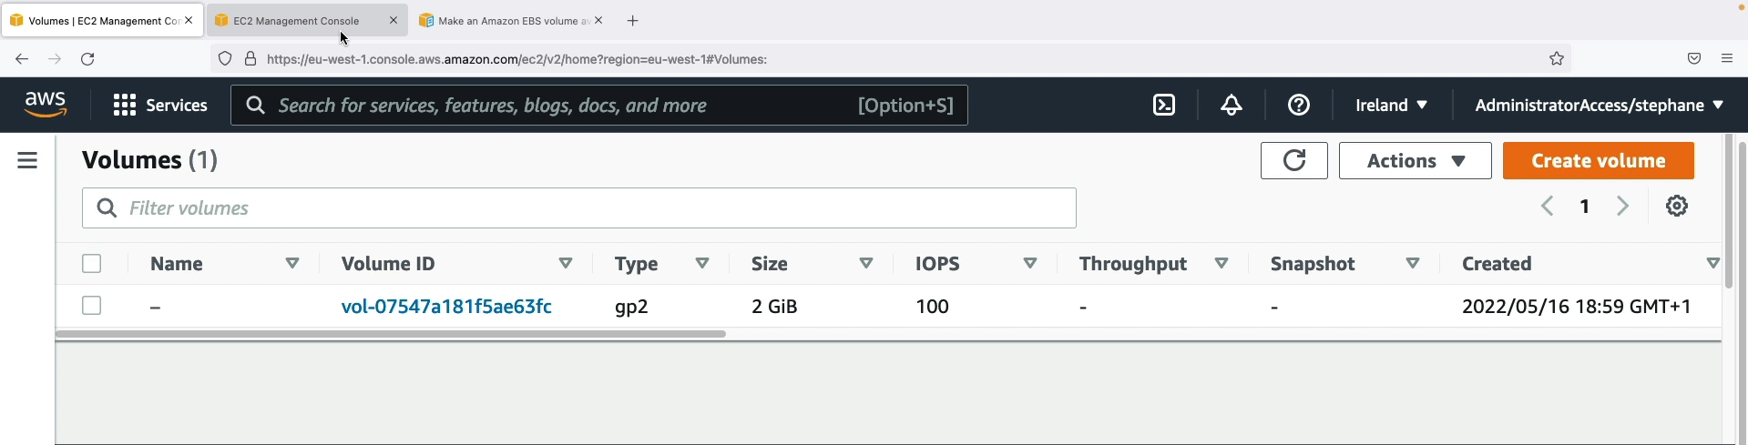

Step 9: Suppose, if we want to delete the instance means then the root volume attached to that instance will get delete automatically. Because, while creating the instance we give the option like delete the volume on instance deletion. Suppose if we don’t want to do that we can change. Only the root volume will get deleted.

1. **EBS Snapshots Overview:**

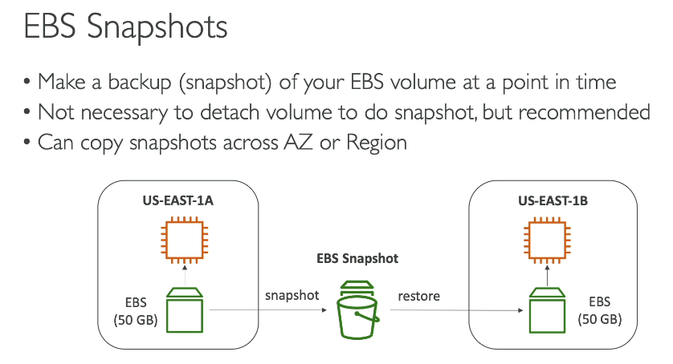

**Key Concepts**

* **EBS snapshots are backups.** They create a point-in-time copy of an EBS volume, allowing you to back up your data. If the original volume is terminated or lost, you can restore it from the snapshot.
* **No detachment needed.** You don't have to detach the EBS volume from the EC2 instance to take a snapshot, but stopping the instance first is recommended for a cleaner backup.
* **Snapshots are for more than just restoration.** They can also be used to move data across different parts of AWS.

**Data Transfer Across Availability Zones (AZs)**

1. **Create a Snapshot:** Take a snapshot of the EBS volume in your current Availability Zone (e.g., us-east-1a).
2. **Restore to a New Volume:** Use the snapshot to create a **new EBS volume** in the target Availability Zone (e.g., us-east-1b).
3. **Attach to Instance:** The new volume can then be attached to an EC2 instance in the destination AZ.

**Extra Points for Clearer Understanding**

* **Snapshots are incremental.** After the first snapshot, all future snapshots only save the data blocks that have changed since the last one. This makes them fast and efficient.
* **Cross-Region Transfer:** You can copy a snapshot from one AWS Region to another. This is the primary method for moving EBS data across different geographical locations, which is vital for disaster recovery and global application deployments.
* **Snapshots are stored on Amazon S3.** Although they appear in your EBS console, the underlying storage for snapshots is Amazon S3, which makes them highly durable and available.

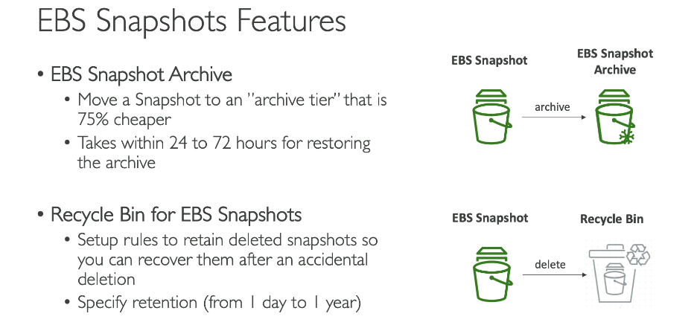

**EBS Snapshot Archive**

* **Cost Savings:** This feature lets you move snapshots to a lower-cost storage tier called an "archive tier." This tier is approximately 75% cheaper than standard storage.
* **Purpose:** It is ideal for snapshots that you need to keep for long-term retention but don't need to access frequently or urgently.
* **Restoration Time:** Restoring a snapshot from the archive tier is not immediate. It can take **24 to 72 hours** to retrieve the data.

**Recycle Bin for EBS Snapshots**

* **Protection Against Deletion:** By default, deleting a snapshot is permanent. The recycle bin feature acts as a safety net to protect against accidental deletion.
* **How It Works:** When you delete a snapshot, it is moved to a recycle bin instead of being permanently removed.
* **Retention Period:** You can configure a retention period for the recycle bin, ranging from one day to one year. After this period, the snapshots are permanently deleted from the bin.
* **Recovery:** This gives you a specified amount of time to recover a deleted snapshot if you change your mind or if it was deleted by mistake.

1. **EBS Snapshots Hands On:  
   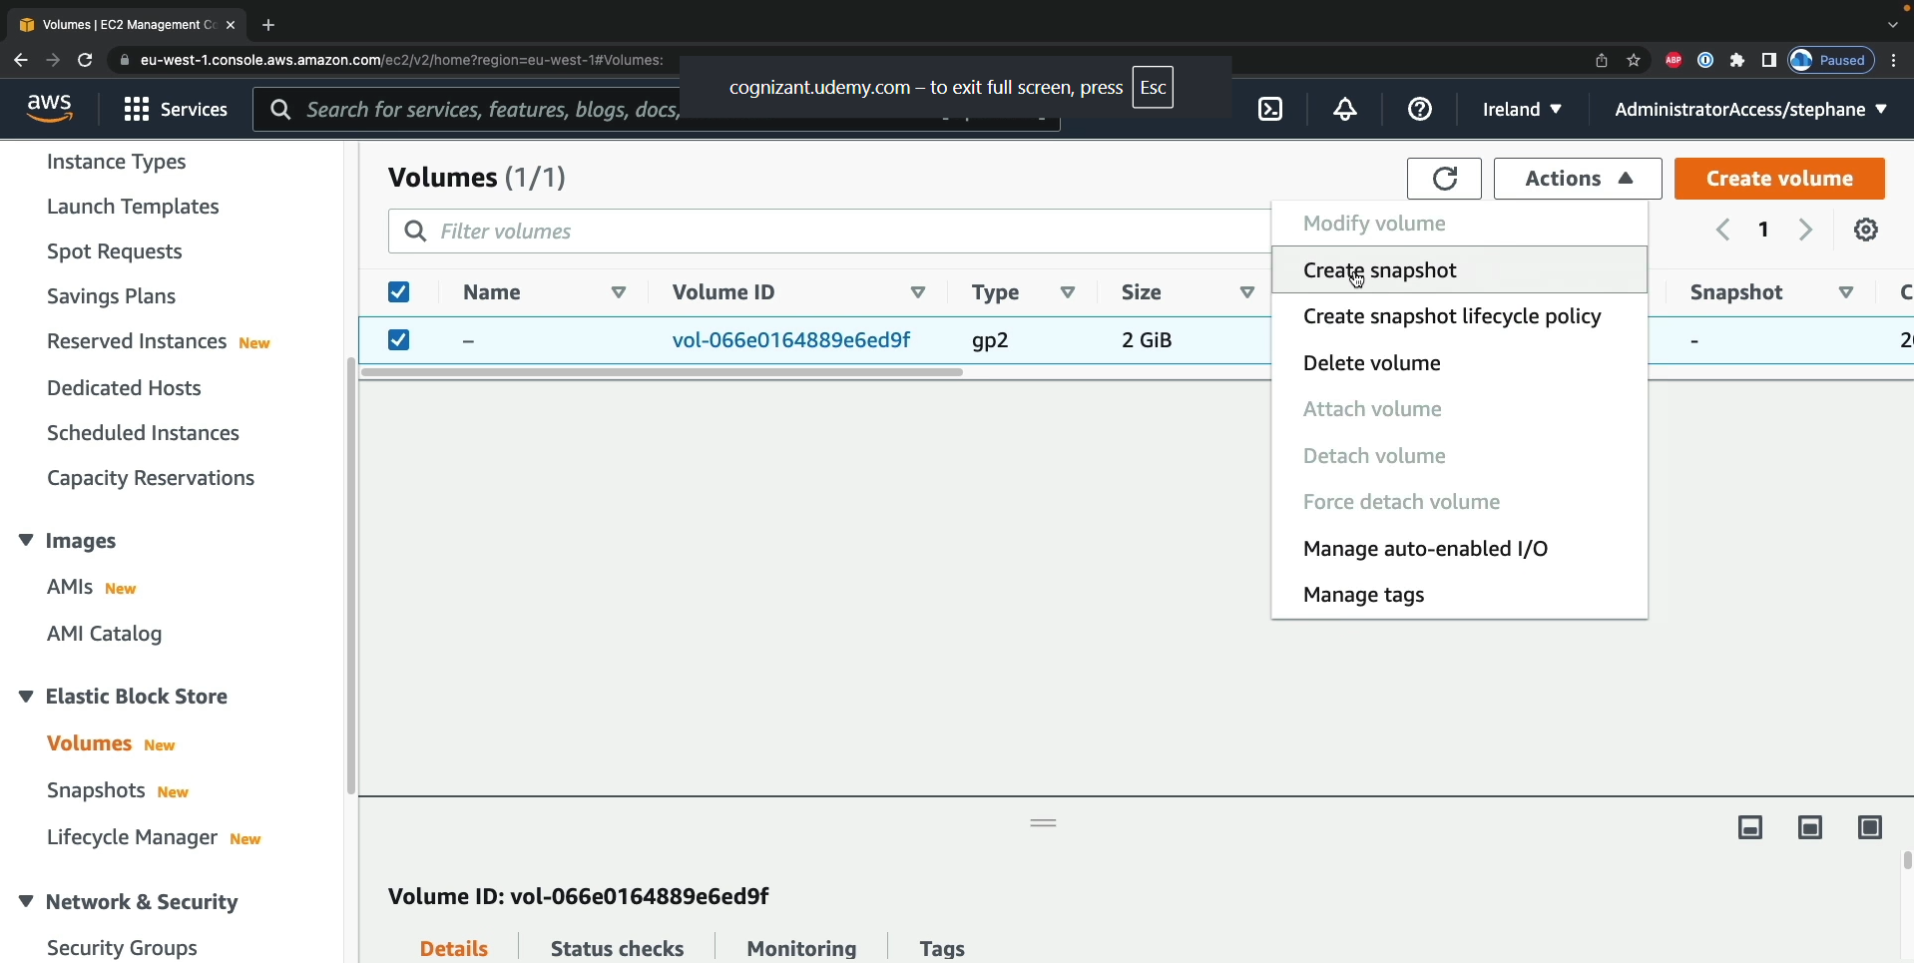**

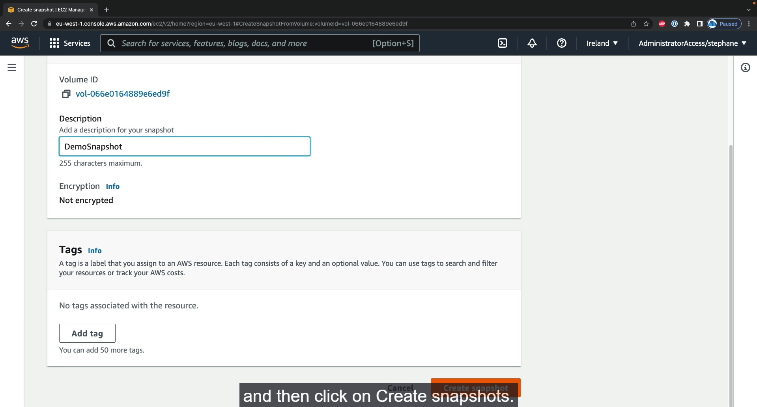

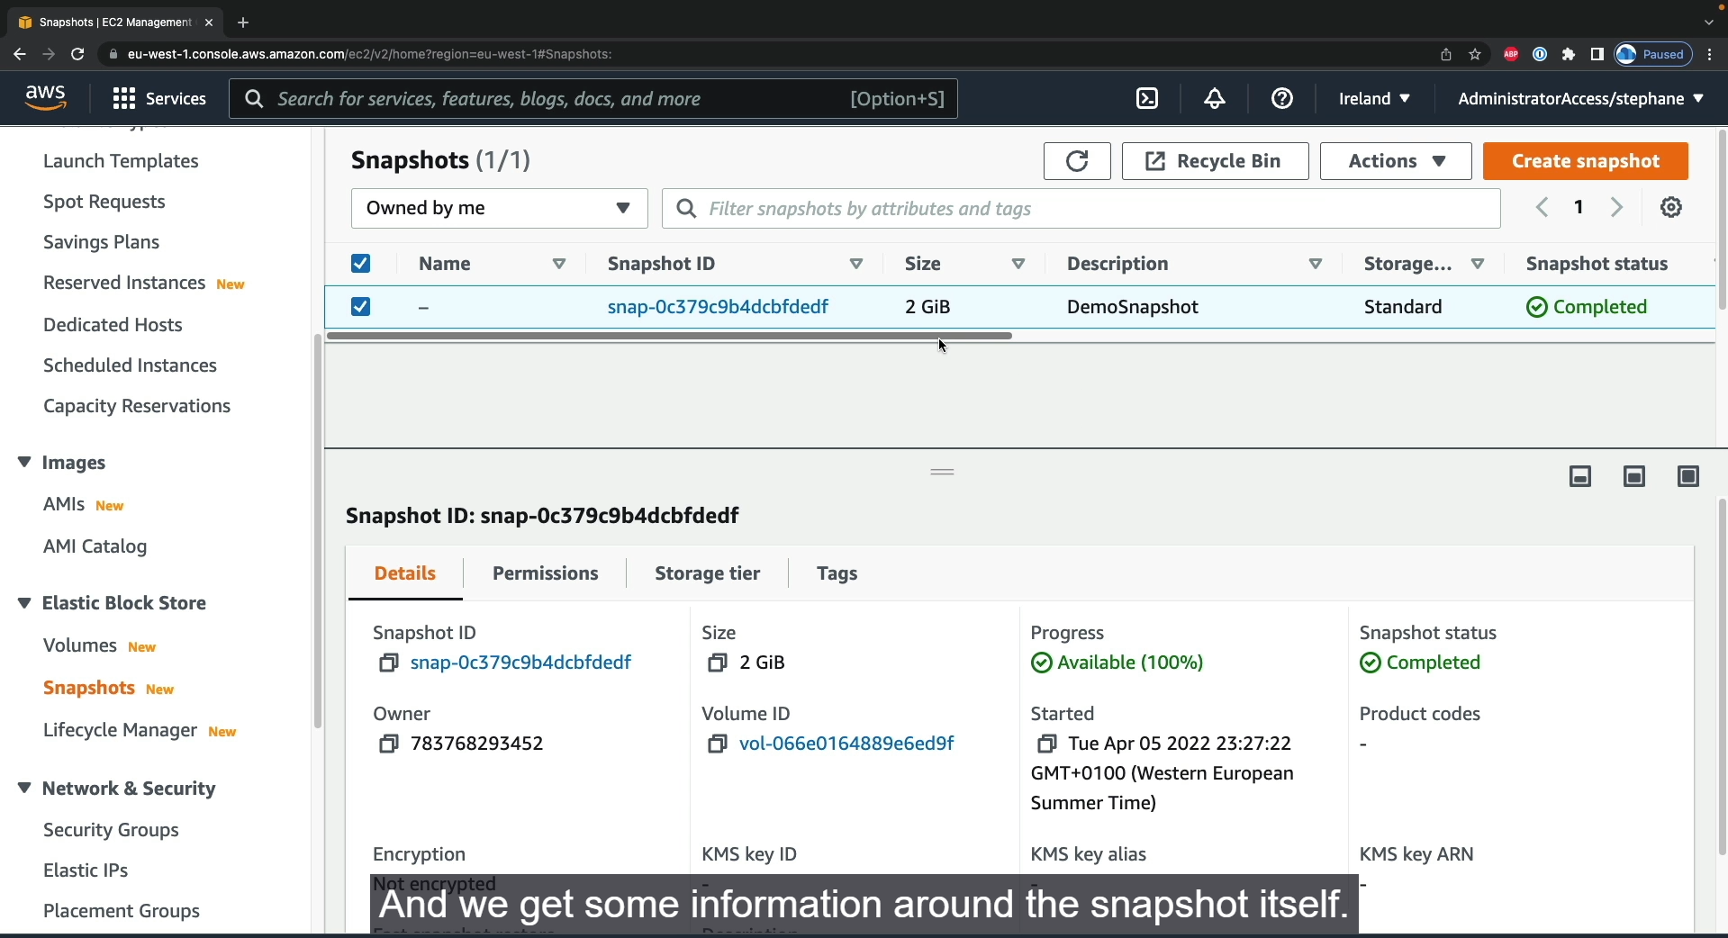

Step1: Select the volume for which you want to create the snapshot. And then select action 🡪 Create Snapshot.

Step2: Enter snapshot settings. Create snapshot. Snapshot created successfully.

Step 3: Left side tab 🡪 EBS🡪 Snapshot 🡪 Snapshot information will available here.

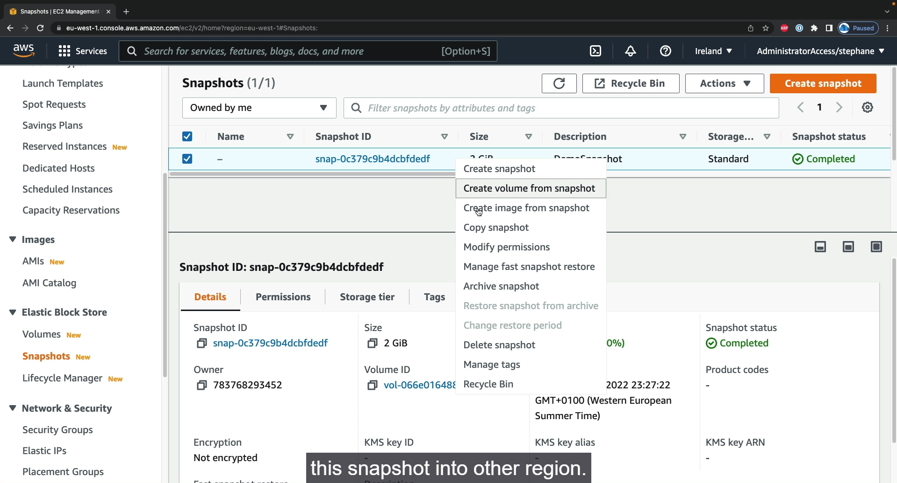

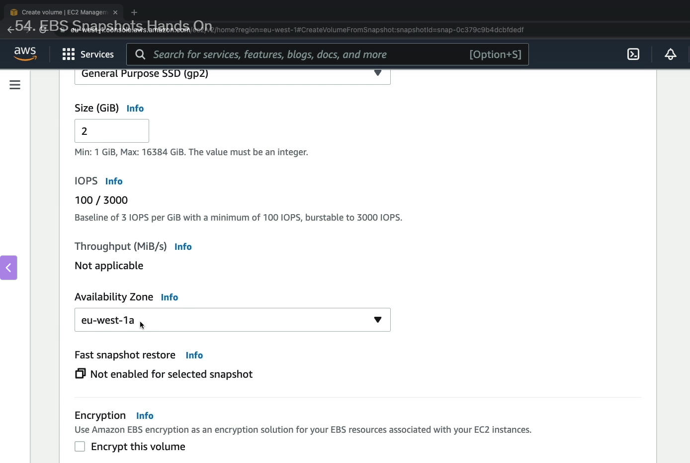

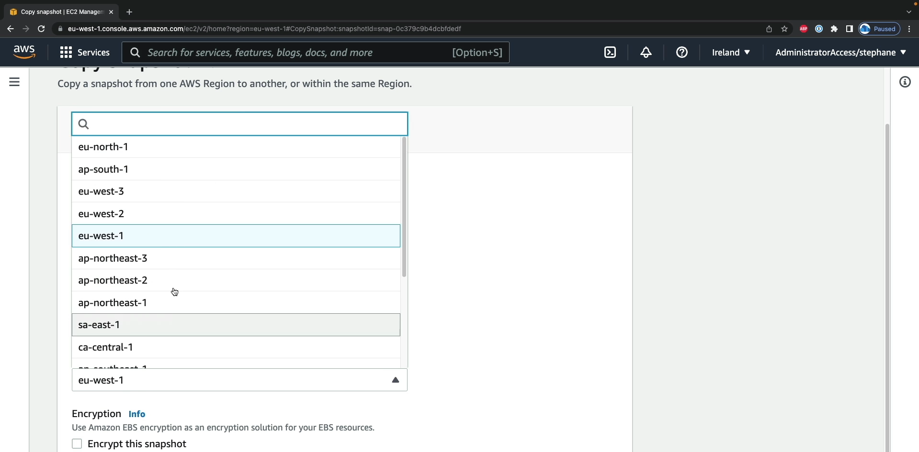

Step 1: We can create the volume from the snapshot which is used to transfer the volume from one AZ to another AZ.

Step 2: Select snapshot 🡪 Actions🡪 Create volume from snapshot.

Step 3: It will enter into snapshot settings. Enter the volume size and Availability Zones. 🡪 Create volumes.

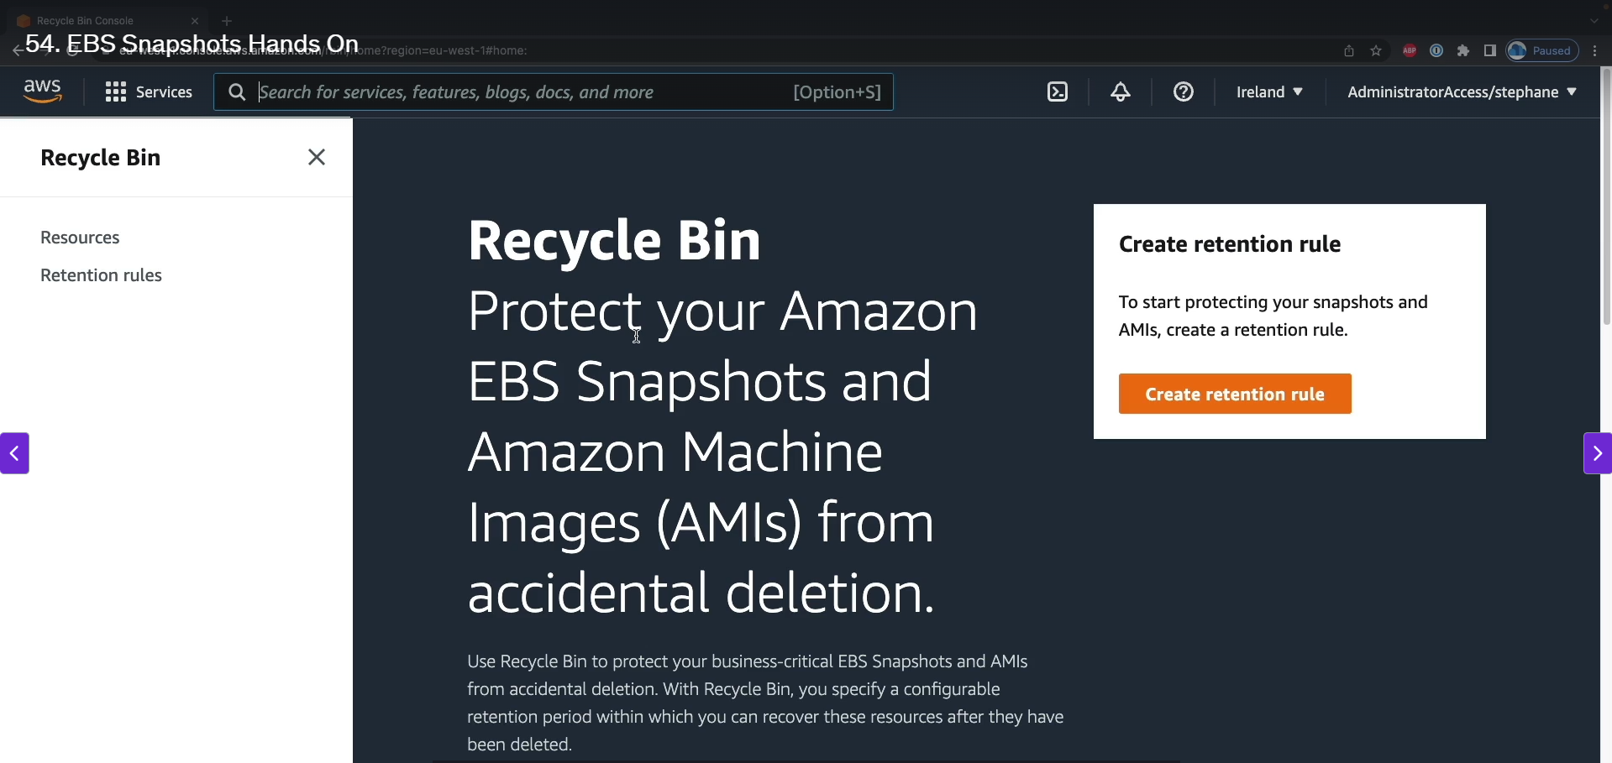

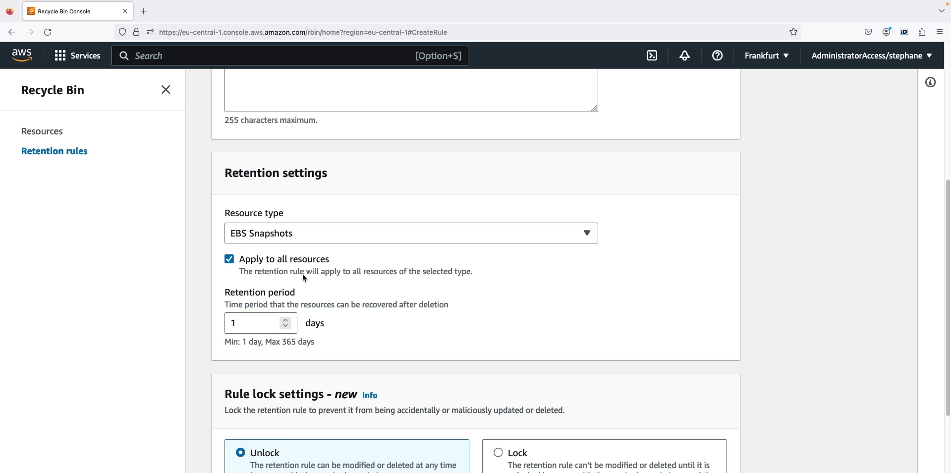

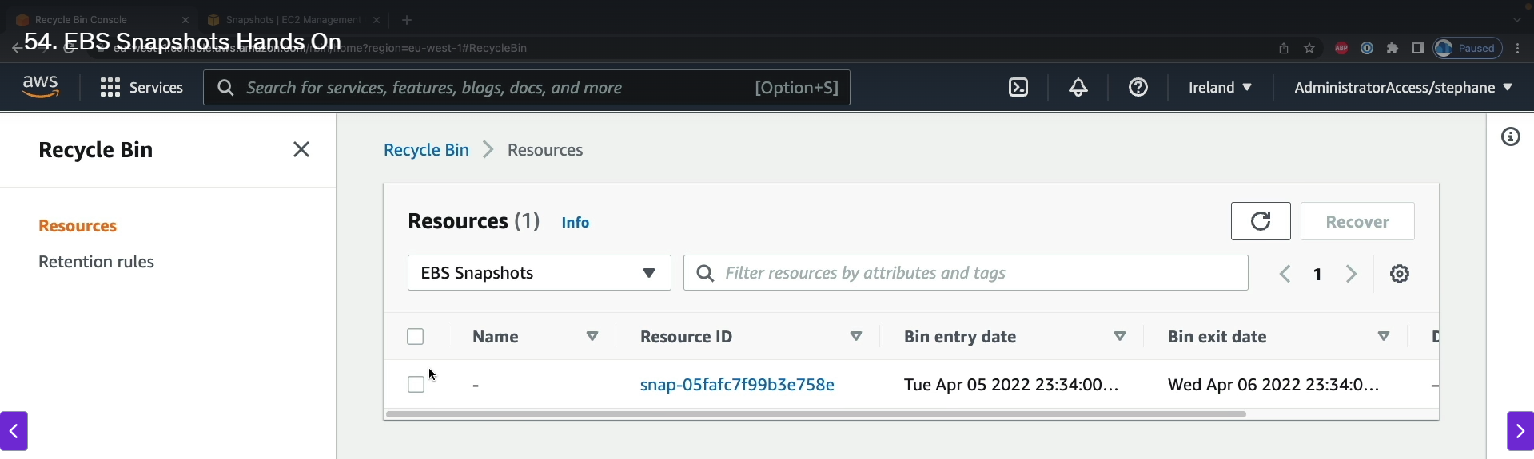

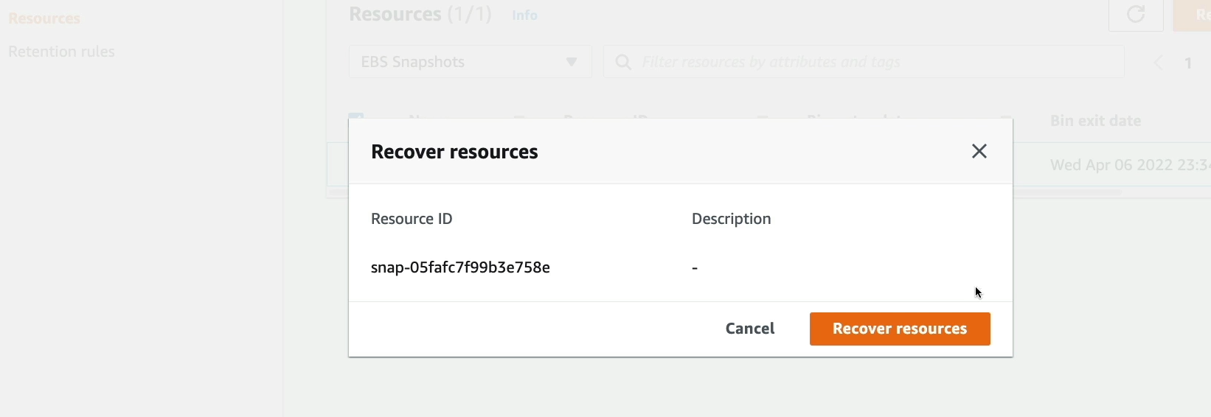

Step 1: Accidentally if we deleted the snapshot means we can recover it from the recycle bin. For that we want to set the retention rule for recycle bin in advance.

Step 2: Search recycle bin 🡪 Create retention rule 🡪 Enter the retention type (EBS or AMI) 🡪 Retention period in days 🡪Create retention rule.

Step 3: If you delete the EBS then we can find it in the recycle bin. We can easily recover it.

Step 4: Select the EBS 🡪 Recover 🡪verify 🡪 Recover resources.

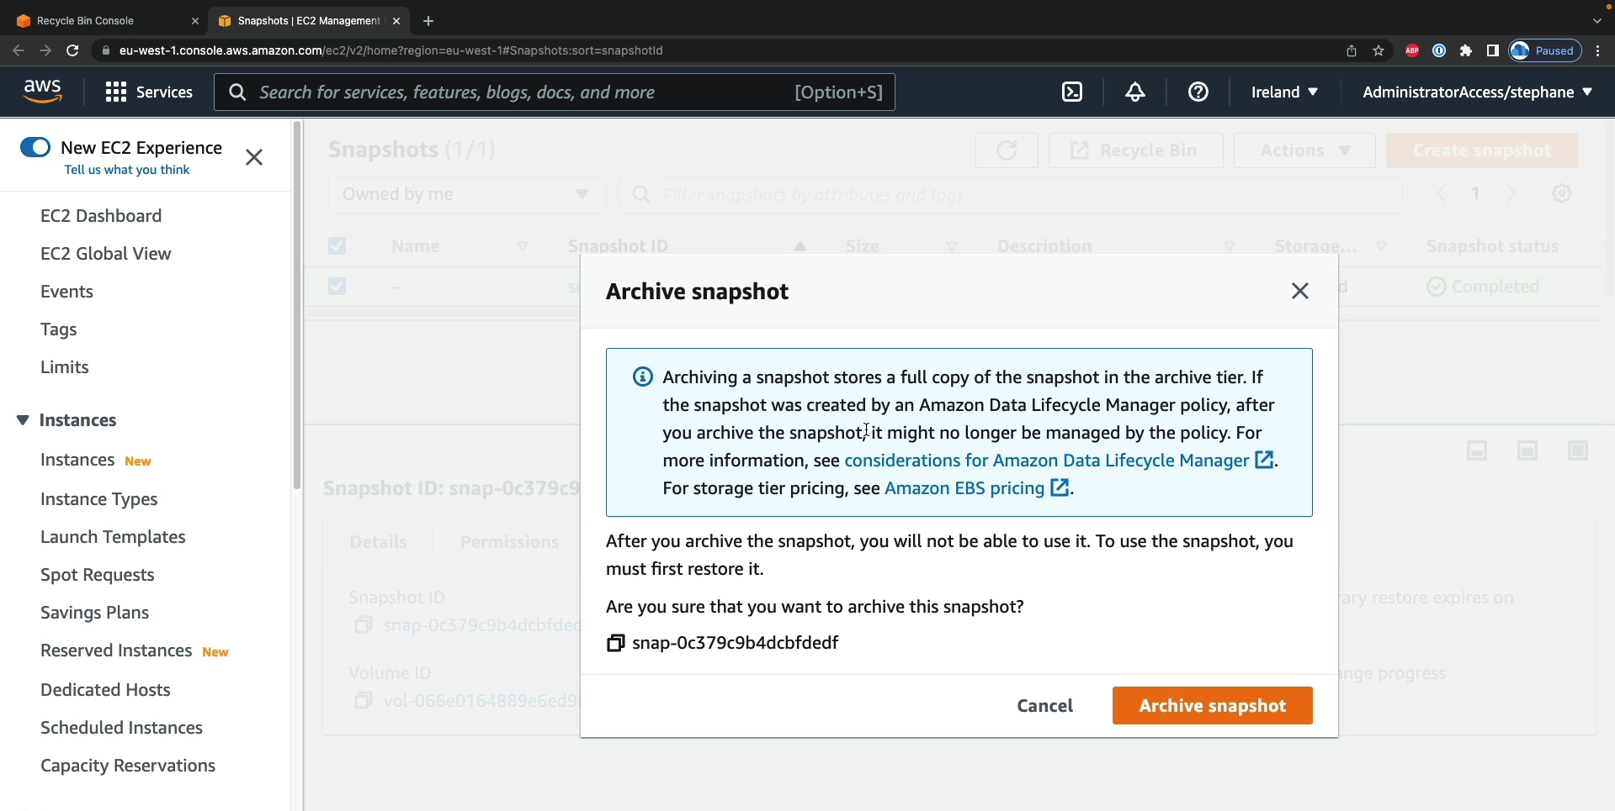

Step 1: We can the store the snapshot in the EBS Archive instead of storing in S3 bucket. Because EBS Archive is low cost compared to S3 bucket.

1. **AMI Overview:**

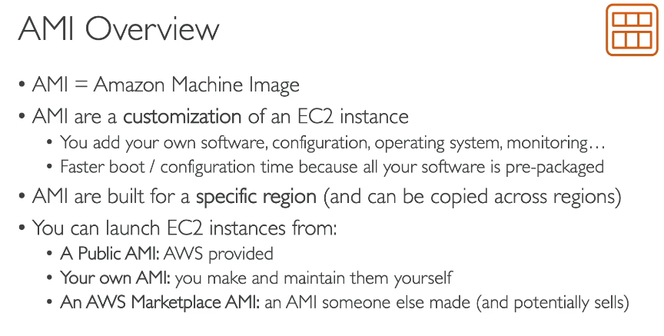

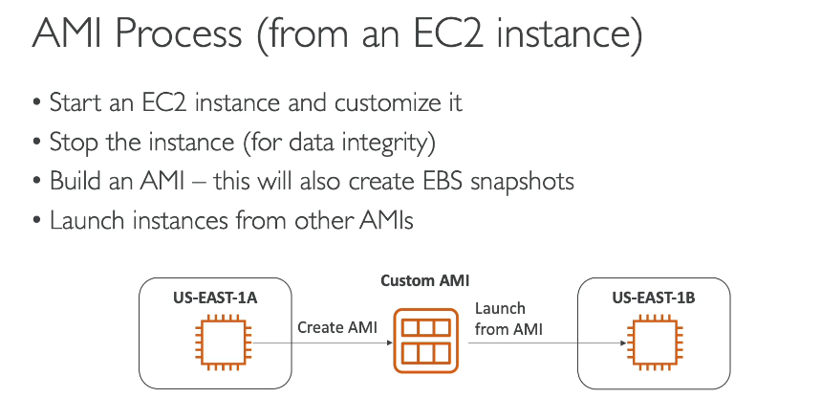

What is an AMI?

An AMI, or Amazon Machine Image, is a template that provides the necessary information to launch an EC2 instance. It is essentially a pre-packaged configuration of an operating system, software, and other settings. Using a custom AMI can significantly reduce the time it takes to boot and configure a new instance because everything is already set up.

Types of AMIs

* Public AMIs: These are provided and maintained by AWS and the AWS community. A common example is the Amazon Linux 2 AMI.
* Custom AMIs: These are created by you from an existing EC2 instance. You are responsible for their creation and maintenance, but they allow you to have a perfectly customized template for your specific needs.
* AWS Marketplace AMIs: These are created and sold by third-party vendors. They often come with pre-installed commercial software, allowing you to save time on manual setup. You can even sell your own custom AMIs on the marketplace.

How to Create a Custom AMI

1. Launch & Customize: Start with an existing EC2 instance and configure it with your desired software, settings, and monitoring tools.
2. Stop the Instance: Stop the EC2 instance to ensure data integrity and a clean snapshot.
3. Create the AMI: From the stopped instance, create an AMI. AWS will automatically create an EBS snapshot of the root volume behind the scenes.
4. Launch from AMI: You can now launch new EC2 instances using your custom AMI, which will be an exact copy of the original instance's configuration.

Extra Points for Clearer Understanding

* Region-Specific: AMIs are specific to the region where they are created. To use an AMI in a different region, you must first copy it.
* Snapshots are the foundation. The AMI creation process fundamentally relies on taking snapshots of the EBS volumes to save the instance's state.
* Cloning Instances: Creating an AMI is the most efficient way to "clone" an EC2 instance and replicate its exact configuration across different Availability Zones or Regions. This is a common practice for scaling applications and ensuring consistency.

1. **AMI Hands On:**

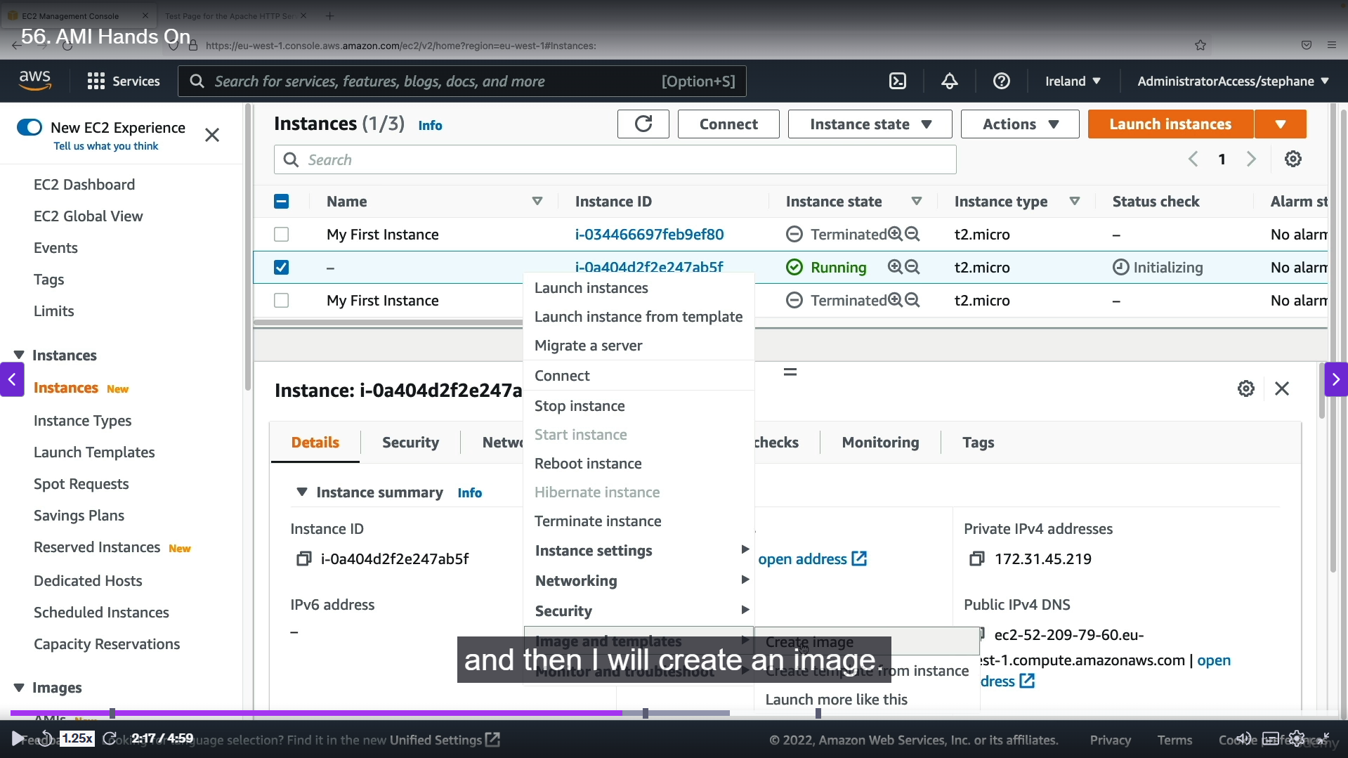

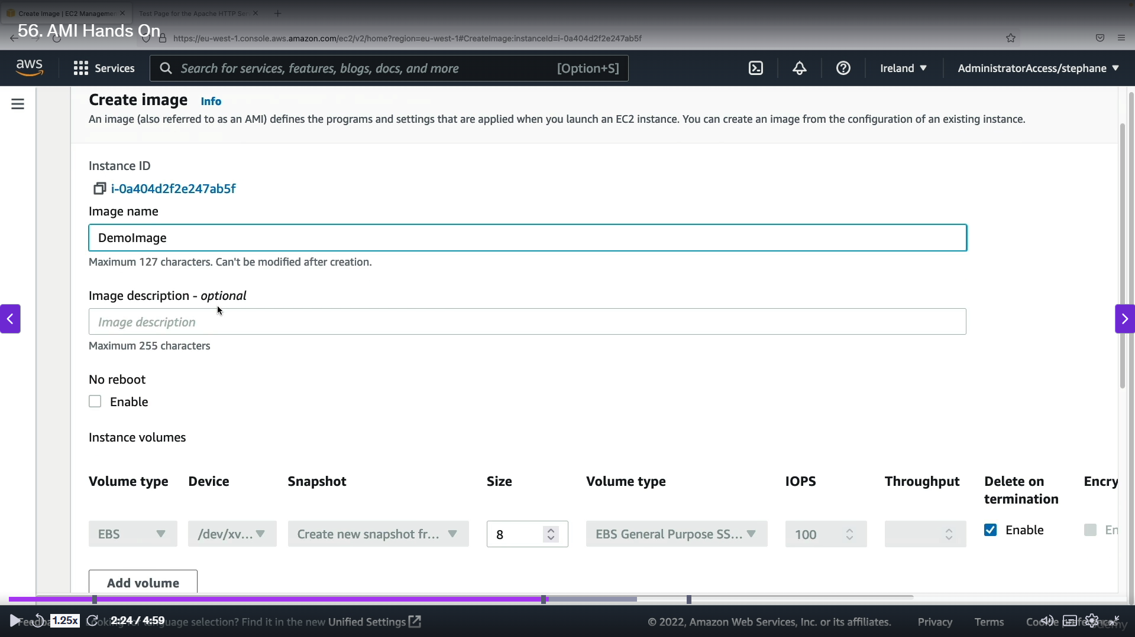

Step 1: For creating the instance we want to select the instance 🡪left click 🡪 Images and templates 🡪 Create Image.

Step 2: Next to AMI setting 🡪 Enter the Image name 🡪 leave all other settings as default 🡪 create IAM image. IAM created successfully.

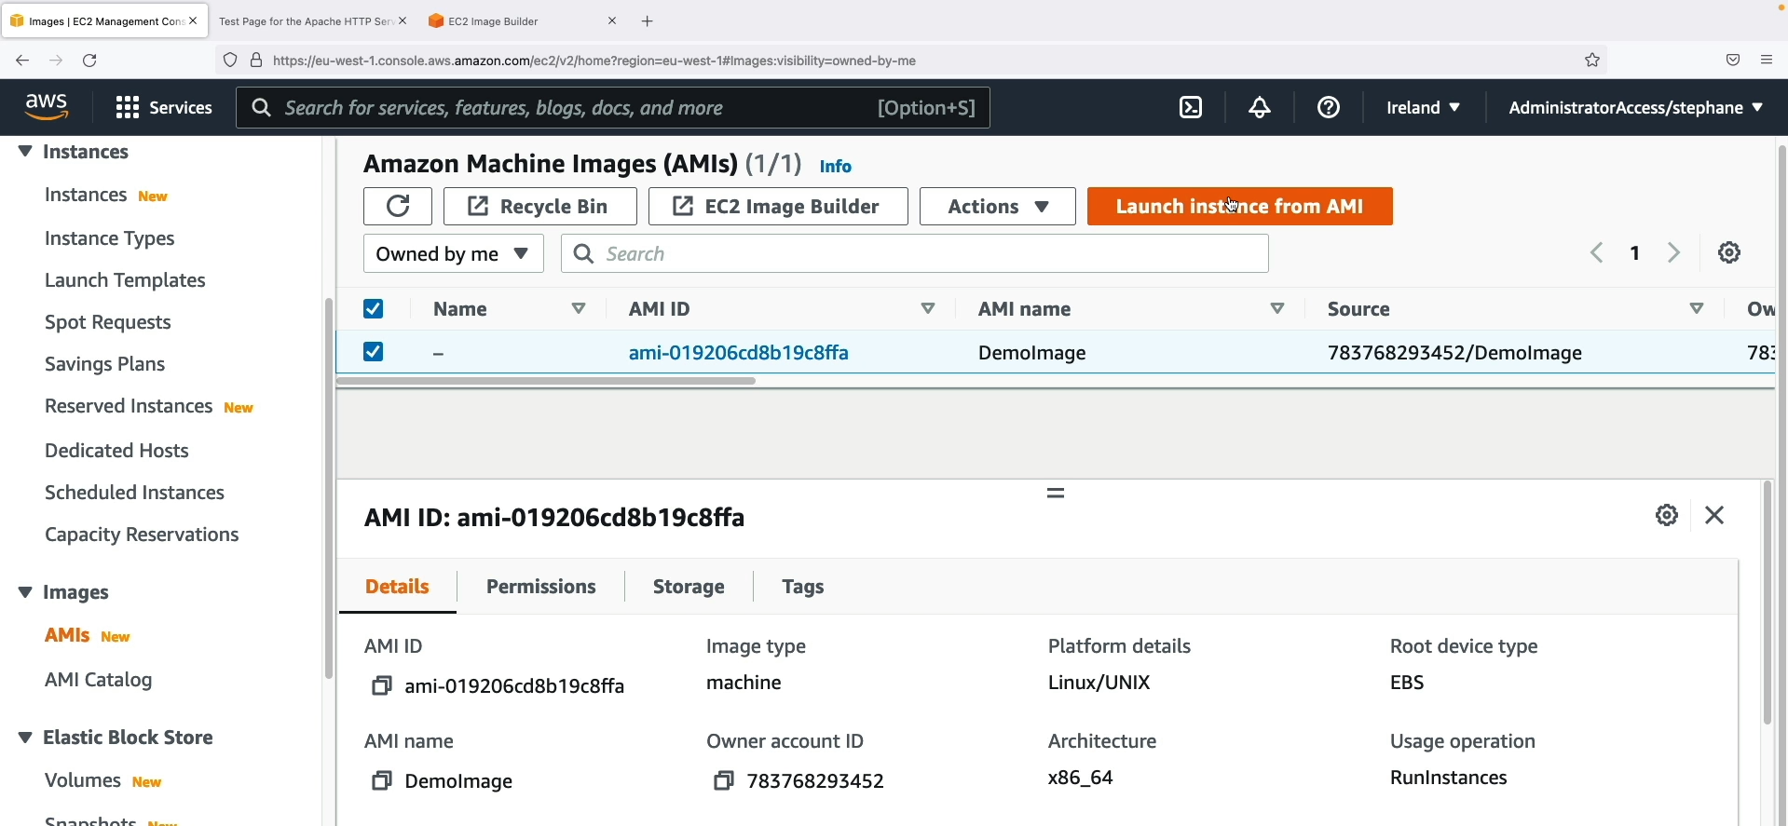

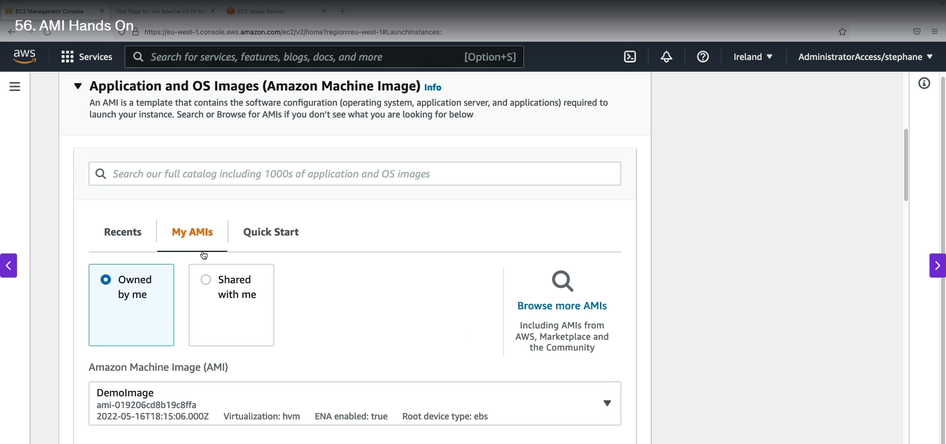

Step 1: If we want to launch the IAM image 🡪 left side 🡪 Images section 🡪 AMI option 🡪 select the instance 🡪 Launch instances from AMI. This is one-way other way is in instances.

Step 2: Select launch instances 🡪 In AMI option 🡪select MY AMIs 🡪 Owned by me 🡪 select the AMI which you want to launch and 🡪 Finally launch the instance as usually.

1. **EC2 Image Builder Overview:**

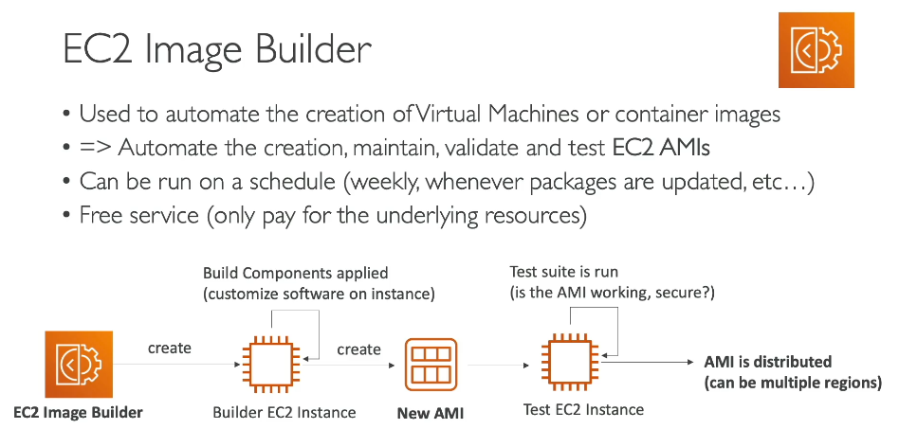

EC2 Image Builder is an AWS service that automates the creation, maintenance, and validation of custom Amazon Machine Images (AMIs) and container images. It simplifies the process of creating secure and up-to-date images.

**How EC2 Image Builder Works**

* **Builder EC2 Instance:** Image Builder automatically launches a temporary **Builder EC2 instance**. This instance is where all the customization happens.
* **Component Installation:** On the Builder instance, the service runs scripts and components that you define. This can include installing software like Java, updating the operating system, or adding security configurations.
* **Automated AMI Creation:** After the customization is complete, Image Builder automatically creates an **AMI** from the Builder instance.
* **Testing and Validation:** A temporary **Test EC2 instance** is launched from the newly created AMI to run predefined tests. This step ensures the AMI is functional, secure, and ready for use.
* **Distribution:** Once the tests pass, the validated AMI can be automatically distributed to multiple AWS Regions, making your application truly global.

**Key Features and Benefits**

* **Automation:** It automates the entire image creation and update pipeline. This is useful for keeping your AMIs consistently patched with the latest software and security updates.
* **Scheduling:** You can run Image Builder on a schedule (e.g., weekly) or trigger it manually, giving you flexibility over when your images are updated.
* **Cost:** EC2 Image Builder is a free service. You only pay for the underlying resources it uses, such as the temporary EC2 instances and the storage costs for the resulting AMIs.
* **Security:** It helps enforce security best practices by allowing you to define and test security configurations as part of the build process.

1. **EC2 Instance Store:**

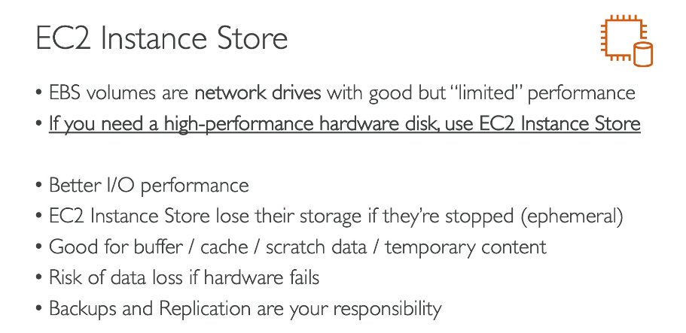

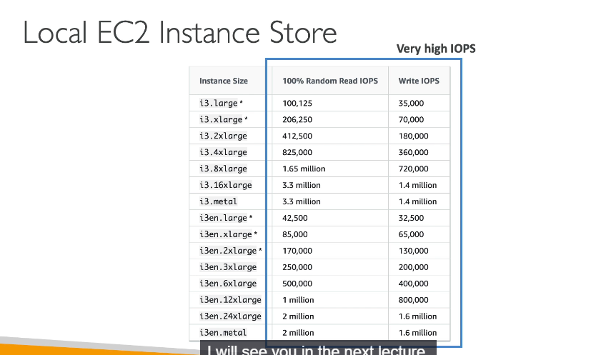

**What is EC2 Instance Store?**

An **EC2 Instance Store** is a local, physical storage drive directly attached to the host server of an EC2 instance. It provides extremely high-performance storage, making it ideal for tasks that require fast read/write speeds.

**Key Features and Characteristics**

* **High Performance**: It offers significantly better I/O performance and throughput compared to network-attached EBS volumes. The text mentions it can handle millions of I/O operations per second (IOPS), far exceeding what typical EBS volumes provide.
* **Ephemeral Storage**: The main drawback is that it is **not persistent**. All data stored on an EC2 Instance Store is lost if the instance is **stopped** or **terminated**, or if the underlying hardware fails.
* **Use Cases**: Because of its ephemeral nature, it is best used for temporary data that can be re-created, such as:
  + Caches
  + Buffers
  + Scratch data
  + Temporary content
* **Risk**: If the underlying physical server fails, all data on the Instance Store is lost. It is the user's responsibility to back up or replicate this data.

**Comparison with EBS**

* **EBS (Elastic Block Store)**: Network-attached, **persistent** storage. Your data remains even if the EC2 instance is stopped or terminated. It's the recommended choice for durable, long-term storage.
* **EC2 Instance Store**: Physically attached, **ephemeral** storage. Data is tied to the life of the instance and is lost upon termination or failure. It is used for performance-intensive, non-critical workloads.

1. **EFS Overview:**

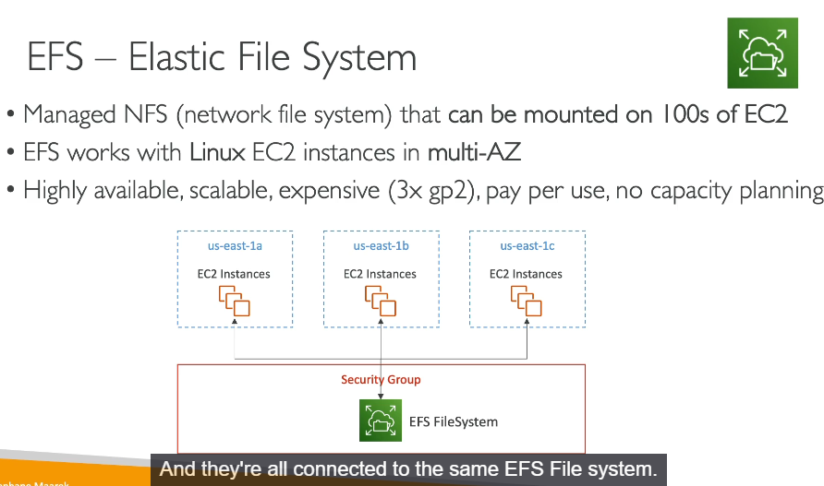

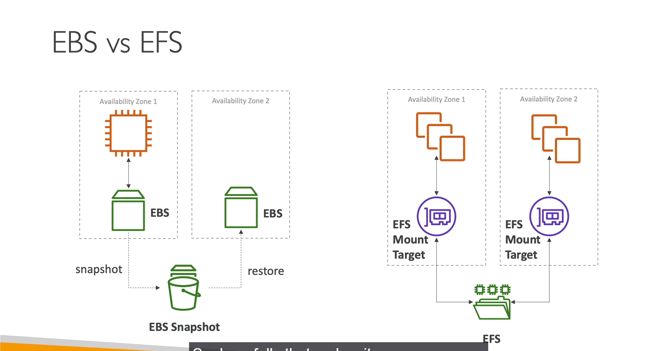

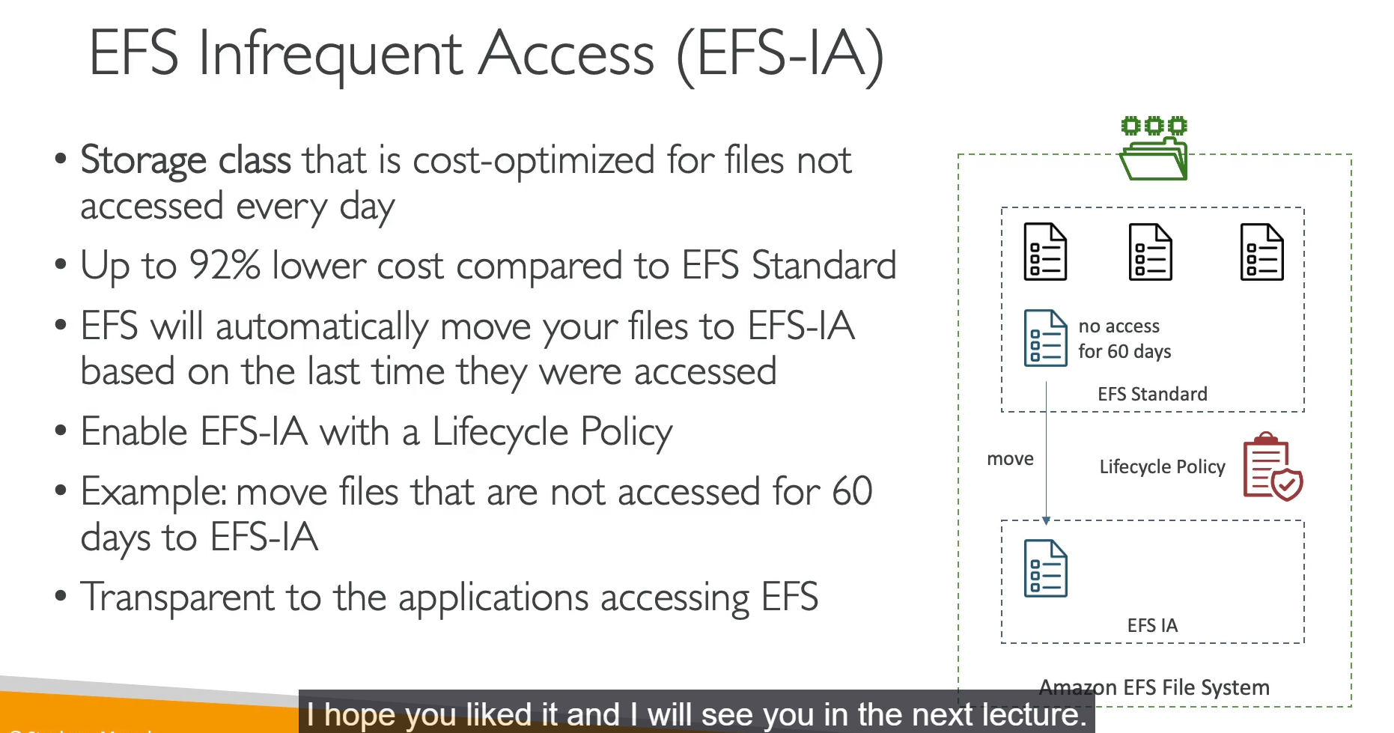

**Key Concepts of Amazon EFS**

* **Shared File System**: EFS is a managed **network file system (NFS)** that can be mounted and accessed by hundreds of EC2 instances at the same time. This makes it ideal for workloads that require shared access to a common set of files.
* **File-Level Storage**: EFS is a **file-level storage** service. Unlike EBS (which is block-level) or S3 (which is object-level), EFS uses a familiar file system hierarchy (folders and subfolders) and the **NFS (Network File System)** protocol, making it easy to use with applications that need a shared file system.
* **Cross-AZ Compatibility**: An EFS file system is a regional resource, meaning it's automatically replicated across multiple **Availability Zones (AZs)**. EC2 instances in different AZs can all connect to and use the same EFS volume.
* **Linux-Only**: EFS works specifically with Linux EC2 instances.
* **Pay-per-Use**: EFS is a "pay-per-use" service. You are only charged for the amount of storage you actually consume, not for a pre-provisioned capacity.
* **Cost**: EFS is generally more expensive than EBS on a per-gigabyte basis, but its shared nature can make it cost-effective for large, multi-instance environments.

**EBS vs. EFS: Key Differences**

* **EBS (Elastic Block Store)**
  + **Access**: Can only be attached to **one** EC2 instance at a time.
  + **Availability**: Bound to a specific Availability Zone. Moving data to another AZ requires creating a snapshot and then restoring it, which creates a copy, not a synchronized replica.
* **EFS (Elastic File System)**
  + **Access**: Can be mounted to **hundreds** of instances simultaneously, allowing them to share the same files.
  + **Availability**: A regional resource that is shared across all AZs, providing high availability. All mounted instances see the same, synchronized data.

**EFS Infrequent Access (EFS-IA)**

* **Cost Optimization**: EFS-IA is a lower-cost storage class for files that are not accessed frequently. It can reduce storage costs by up to 92% compared to the standard EFS storage class.
* **Automatic Tiering**: You can enable a **lifecycle policy** on your EFS file system. This policy will automatically move files that haven't been accessed for a specified period (e.g., 60 days) from the expensive standard tier to the cheaper EFS-IA tier.
* **Transparency**: The process is transparent to your applications. When a file in EFS-IA is accessed again, EFS automatically moves it back to the standard storage class for better performance.

1. **Shared Responsibility Model for EC2 Storage:**

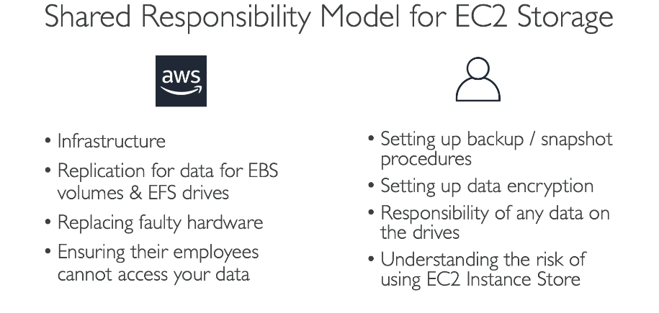

1. **Amazon FSx Overview:**

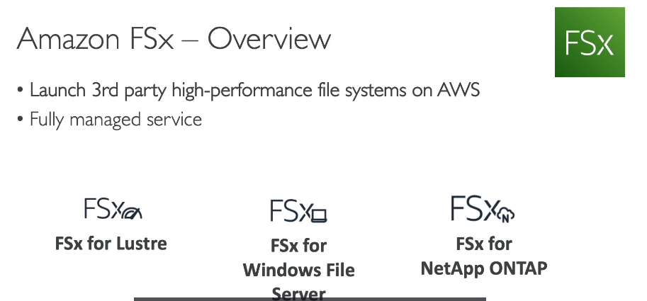

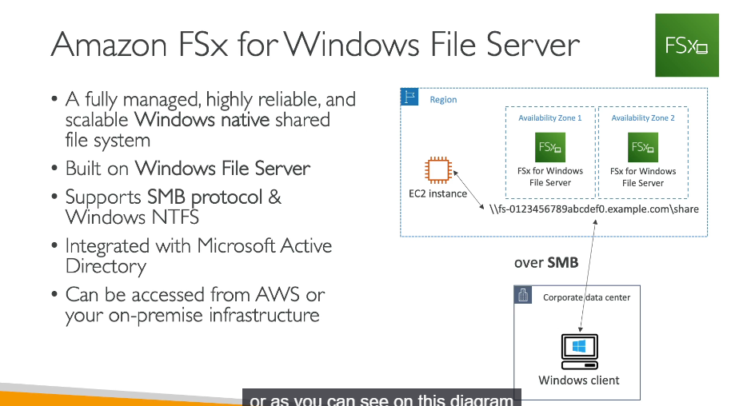

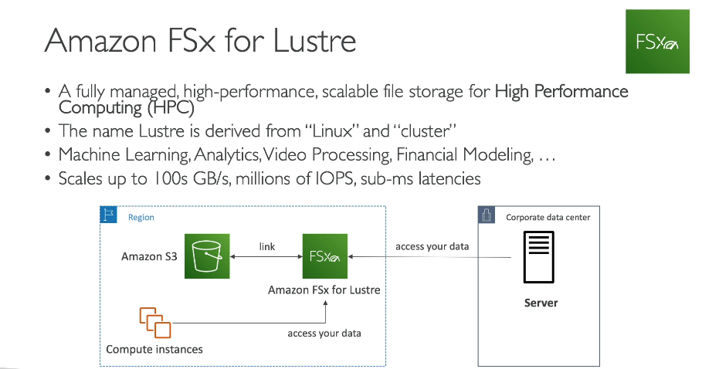

Amazon FSx is a managed service that provides third-party, high-performance file systems on AWS. It allows you to use file systems other than EFS or S3 and is designed for specific enterprise and high-performance computing (HPC) workloads. The two main types covered are FSx for Windows File Server and FSx for Lustre.

**FSx for Windows File Server**

* **Purpose**: This is a fully managed, scalable, and native Windows shared file system. It's for workloads that require compatibility with Windows' file sharing protocols.
* **Key Features**:
  + **Windows Native**: Supports standard Windows protocols like **SMB (Server Message Block)** and **Windows NTFS**.
  + **Integration**: Integrates with **Microsoft Active Directory** for user authentication and security.
  + **Access**: Can be accessed by both Windows EC2 instances within AWS and by on-premises Windows machines.
  + **Deployment**: Typically deployed across two Availability Zones for high availability.

**FSx for Lustre**

* **Purpose**: This is a high-performance, scalable file storage service specifically designed for **High Performance Computing (HPC)** workloads. The name "Lustre" is a portmanteau of "Linux" and "cluster."
* **Key Features**:
  + **Performance**: Provides extremely high throughput (hundreds of gigabytes per second) and millions of IOPS, with sub-millisecond latency.
  + **Use Cases**: Ideal for data-intensive workloads such as machine learning, big data analytics, video processing, and financial modeling.
  + **Integration**: Can be linked to compute instances in AWS or on-premises environments. It can also store its data directly in an **Amazon S3 bucket** for durability and scalability.

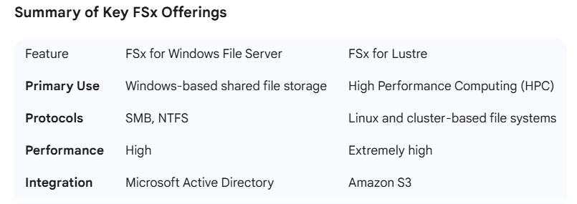

1. **EC2 Instance Storage Summary:**



